Backend

On the Backend Improvement section It has been added.

1. The search pattern for user-defined resource is 2,3 and 4 respectively. The site is not a duplicate site.

There is a test case that simulates testing and testing in the link below.

2. The resource is divided into two parts, which are not equal. And the remaining resources will be paid to the sites that are available.

<https://drive.google.com/file/d/1GURlXjsS2BAx4JB7ZlJfdYU5AfQ8owry/view?usp=sharing>

3. The resource is divided into two parts is not equal. By checking for sites that can maximize resources, and then finding the resources left over from the site (incomplete)

this section also contains some of the problems and fixes that can be correct.there is no confirm structure that is not included in the system, but we will update in the future.

The search is required to log in and have resources available to the system resources and need to go through the entire map window in a map of the world. Remember to select the search menu.

Search process

1. Search does not need to log in.

2. Click the "magnifying glass"

3. Enter the resource details you want to reserve.

4. Click the Search button.

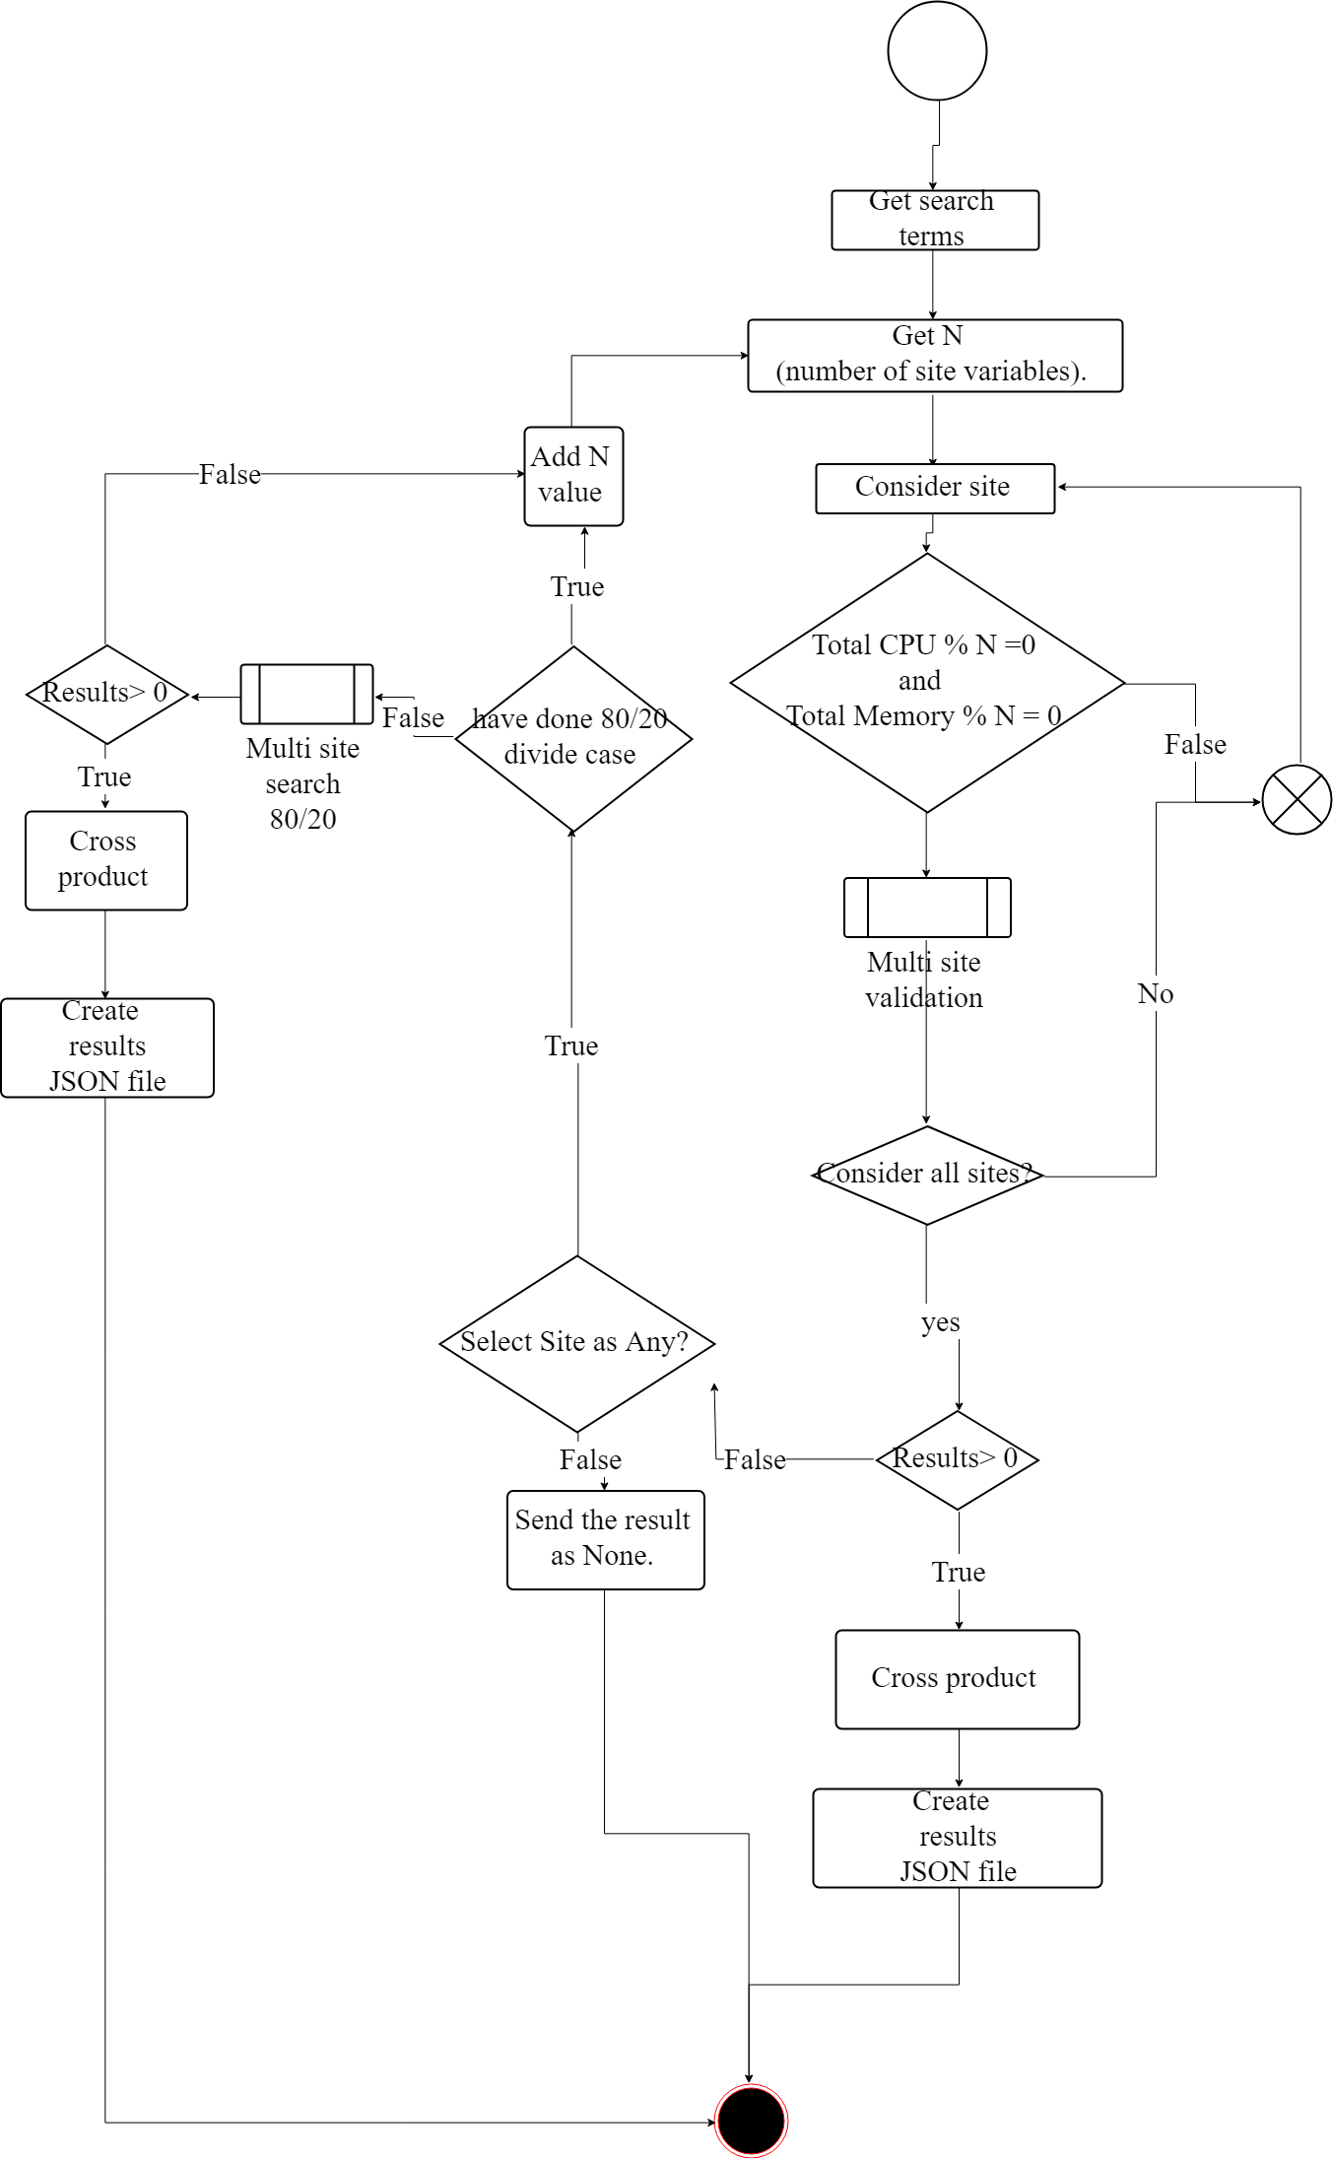

Multiple-site search results (short form)

Reservation

Reservations in the back section end is changed to the database in the table. Site_reservation by adding a key In the table to increase the booking conditions and to add the check in the booking system once. To prevent duplicate bookings at the same time, or to search after reservations that may have occurred in the case of a resource that does not correspond to the actual resource.